**Sarthak Bhatnagar**

Certified Salesforce Developer, proficient programmer, critical thinker and eager for new experiences.

Seeking software engineer position.

**key skills**

**experience**

**Salesforce Developer April 2019 - Present**

Akidev Corporation Fremont, CA

* Developing Lightning Components, Visualforce pages, Apex Classes and Triggers to improve user interaction with the Salesforce database.
* Integrating with third party applications using REST and SOAP APIs.
* Providing onsite support and debugging production issues to prevent interruptions in client’s custom Sales and CPQ process.
* Collaborating with other SFDC developers and architects using the Agile methodology and Assembla as the project management tools.

**Advance IT Technician April 2016 - December 2018**

Information Technology Services Storrs, CT

* Supported UConn students and staff in identifying, troubleshooting and resolving computer software, hardware and network related issues in Windows, OS X and Linux environments.
* Responsible for training sessions for the new and returning student employees before the start of every semester.
* Performed QA on the technical tickets worked on by new and current technicians.

**Mobile Application Development Intern June 2017- August 2017**

Evalueserve.com Gurgaon, Haryana, India

* Collaborated with a team of software engineers to build a hybrid mobile application which combines Evalueserve’s Admin, IT, Transport and HR help desk databases into a unified mobile app.
* Developed a UI using the Ionic Framework, implemented hybrid and native functionalities, using JavaScript and Cordova to improve communication with the back-end service and the overall user experience.

**education**

**University of Connecticut Storrs, CT**

**Bachelor of Science December 2018**

**Major: Computer Science, School of Engineering**

Relevant Courses:

* Computer Network and Data Communication (Python)
* Systems Programming (C and Linux)
* Artificial Intelligence
* Data Structures and Algorithms (Java)
* Software Engineering (Java)

**projects**

**Java Developer September 2017 – April 2018**

UConn Senior Design Project, Pitney Bowes Storrs, CT

* Develop Java test code to monitor if mailing workflows, executed with using Camunda and Apache Tomcat, passed the pre and post condition
* Developed a methodology describing our process so that it can be adapted to Pitney Bowes’s other workflows.

**Lead Developer March 2108**

UB Hackathon Bridgeport, CT

* Developed the UI for a hybrid mobile app, that provides a safe driving service to university student by other university students, using the Ionic Framework
* Implemented Firebase for user authentication and data storage and tested by deploying to both Android and iOS devices using Cordova and npm.
* Created and maintained a Git repository for smooth collaboration.

**Programming Languages:**

Java, C, Python

Apex, JavaScript,

SQL, SOQL/SOSL,

HTML/CSS

**Software:**

Lightning Components, AWS

Visualforce Pages, Git,

PowerShell, Ionic Framework

**Tools**:

Jira, Assembla, Postman,

SOAPUI, Data Loader

**Language Proficiency:**

English - Conversational

Hindi – Conversational

French – Intermediate

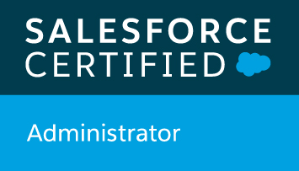

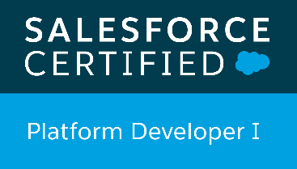

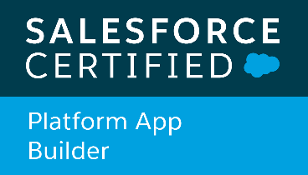

**personal info**

**Email:**

sbha092@gmail.com

**Website:**

www.sarthakbhatnagar.info

**Work Eligibility:**

OPT with a valid EAD